Child Care or Preschool Tax Statements

Tax statements for Child Care or Preschool accounts are available beginning January 1 for the previous calendar year. Once logged in, account owners can select their child care account number under the Your Accounts section of the Dashboard. Use the green Download Tax Information button from the Account Management Tools on the left to obtain a copy of the PDF report. If your student(s) attended more than one Program, there will be a separate report for each.

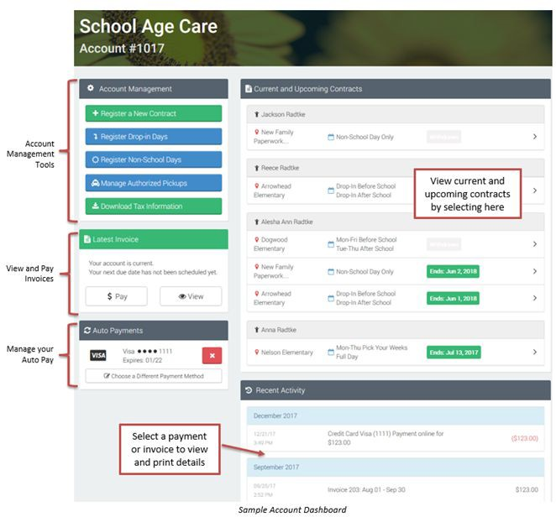
Rev 2022 Powered by

